**Department of Computer Science and Engineering**

|  |  |
| --- | --- |
| **Course Code: CSE 420** | **Credits: 1.5** |
| **Course Name: Compiler Design** | **Semester: Summer 2020** |

**Lab 02**

**Introduction**

**I. Topic Overview:**

The lab is designed to introduce the students to the basics concept of a compiler Design. As part of this activity students will write code for a fixed set of regular expression without using any built in libraries. Basic techniques of coding and required tools will also be shown to students.

**II. Lesson Fit:**

The lab gives a hand on experience of the knowledge of theory class of Lexical Analysis.

**III. Learning Outcome:**

After this lecture, the students will be able to:

a. Understand and visualize the Lexical Analysis phase.

b. Converting regular expression to DFA.

c. Creating own version of Lexical recognizer.

**IV. Anticipated Challenges and Possible Solutions**

a. Mapping the regular expression to DFA will be challenging.

**Possible Solutions:**

a. Use regular expression to guide the DFA.

b. Use methods of java switch case construct.

**V. Acceptance and Evaluation**

If a task is a continuing task and one couldn’t finish within time limit, he/she will continue from there in the next Lab, or be given as a home work. He/ she have to submit the code and have to face a short viva. A deduction of 30% marks is applicable for late submission. The marks distribution is as follows:

Code: 0%

Viva: 100%

**VI. Activity Detail**

**Activity Detail**

**a. Hour: 1, 2**

**Discussion:** Converting Regular Expression to Transition Diagram or DFA.

**Problem Task: Task 1 (page 3-4)**

**b. Hour: 3**

**Discussion:** Code the equivalent DFA for the RE.

**Problem Task: Task 2 (page 3-4)**

**Assignment 3: Problem Description**

In this assignment, you will work on regular expression. For simplicity, we will assume that there is a fixed set of regular expressions. We will not consider out of these. But you must not use any built-in method or package in your implementation. If you need any method, you will write that. In Regular Expression (RE), '*' means occurrence of zero of more characters, '+' indicates happening of one or more characters, '?' means only once or not at all occurrence, '[ ]' indicates happening of inclusive characters, '^' indicates that next characters will not be used in the pattern, '[a-d]{3}' indicates that valid string will be exactly of length 3 inclusively using a, b, c, d. The following table contains a fixed set of RE that will be used in our assignment.

|  |  |  |  |
| --- | --- | --- | --- |
| **Description** | **RE** | **Valid** | **Invalid** |
| Email Address | Find yourself | abc@gmail.com | 123abc@gmail.com |
| Web Address | Find yourself | www.abc.com | www.abc.com |

**Lab 3: Activity List**

**Task 1:** The best way to approach this problem is to draw DFA and translate the DFA in code. Consider the following Transition Diagram for relational operators.

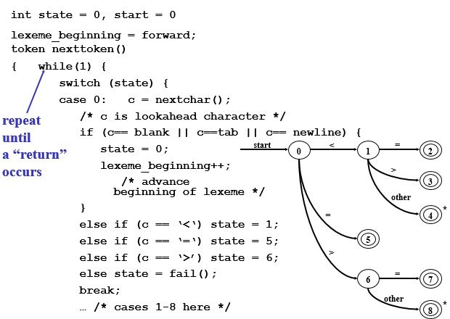

**Task 2:** User will be asked first to input an integer value n followed by n lines of Strings. You have to find out whether it is email or web address along with its line number. **Remember, in no way you can use any kind of built in Regular Expression for this task.**

**Input:**

2

dilrubashowkat@gmail.com

www.dilrubashowkat.com

**Output:**

Email, 1

Web, 2